MTA SZTAKI

CENTER OF EXCELLENCE

Deliverable D 11.5

Organisation of workshops and conferences
Report

Version 1.00j
April, 2004
Table of content

1 Info day on FP6 IST Programme, Call 2 Software Technologies and Distributed Systems 3
1.1 Goals 3
1.2 Agenda 3
1.2.1 Individual presentations from participants 4
1.3 Infoday participants 4
1.3.1 Countries 4
1.3.2 Organizations 5
1.4 Achievements 6
1.5 Feedback Form 6
2 Ideal-ist Event "Information Society Technologies in the Sixth Framework Programme„ 7
2.1 Goals 7
2.2 Agenda 7
2.3 Workshop participants 9
2.3.1 Countries 9
2.3.2 Organizations 9
2.4 Achievements 9
2.5 Feedback Form 10
3 The 2nd CBSEnet Workshop 11
3.1 Goals 11
3.2 Agenda 11
3.3 Participants 12
3.4 Achievements 13
3.5 Parallel sessions 13

Info day on FP6 IST Programme, Call 2
Software Technologies and Distributed Systems

Budapest, Hungary
2nd of April 2003
organized by EU DG INFSO D3 & the Quality Management Department of MTA SZTAKI.

http://istok.sztaki.hu/infoday/

Goals

- Information Day in the Domain of Software technologies and Distributed Systems of the IST Programme
- This event focused on the Strategic Objective of the 2003/04 IST Workprogramme "Open Development Platforms for Software and Services" and aims in particular to further inform participants of Associated Candidate Countries (ACC) on possibilities of participating in IST and to bring them in contact with EU participants in the field.

Agenda

08:00-09:15 | Registration
09:15-09:30 | Opening, welcome  Peter Inzelt - MTA SZTAKI
09:30-09:45 | FP6 and its IST thematic priority  Jacques Bus - EC
09:45-10:15 | The strategic objective "Open development platforms for software and services"  Jacques Bus - EC
10:15-10:45 | FP6 Instruments: what is new  Vassilis Kopanas - EC
10:45-11:00 | Coffee break
11:00-12:00 | Ongoing research road-mapping activities  - Project CBSEnet : Component-based software engineering  Eva Feuer - MTA SZTAKI  - Project MIDAS: Middleware for services  Santosh Shrivastava - Newcastle University
12:00-12:30 | Questions and Answers
12:30-13:30 | Lunch
13:30-14:15 | Strengthening the participation of Associated Candidate Countries in FP6, IST  IDEAL-IST  Paul Drath - Singleimage Limited
14:15-15:45 | Individual presentations from participants  (depending on the number of participants this may be organised in 2 parallel sessions focusing on different topics)
15:45-16:00 | Coffee break
16:00-17:30 | Open networking session  (EC officials will be available for clarifications)

Individual presentations from participants

- Open Schema for Industrial Interoperability Dr. Matevz Dolenc (University of Ljubljana)
- Visiprog - Add-on tool to eliminate hand coding Mr Grzegorz Falda (CERES)
- Department of distributed Systems András Micsik (MTA SZTAKI)
- Silesian University of Technology, Institute of Computer Science Dr. Rafal Cupek (Silesian University of Technology)
- Project Idea: Light integration of heterogeneous engineering tools Mr Loïc Briand (Thales Research & Technology)
- NGN concept Dr. János Kovács (MATÁV Rt. – PKI)
- Information day on FP6 Mr. Tor Ulsund (abelia)
- FP6 IST Infoday at SZTAKI Mr. Tomas Dulik (IIT FT UTB, UNIS)
- FP6 IST Programme - UBB Proposal Dr. Dan Chiorean (LCI UBB Cluj-Napoca)
- Introduction of Régens IT Plc. Mr Tamás Gaizer (Régens Rt.)

Infoday participants

Participating European countries

Country Number of participants
Austria 3
Belgium 1
Bulgaria 1
Czech Republic 1
France 2
Germany 1
Greece 4
Hungary 52
Italy 1
Norway 2
Poland 5
Romania 6
Slovakia 4
Slovenia 1
Spain 1
Turkey 4
United Kingdom 6
Total 95

Participating organizations

Aitia Inc.
AltaCom Ltd.
ATC
ATYS-co Ltd.
Babes-Bolyai University
Bene-ProFit Bt
Bravida
Budapest University
BUTE
CERES
Comptifex-Z Ltd.
EC, DG INFSO D3
Engineering Ingegneria Informatica S.p.A
EQNet Telecommunication and Information Comp.
ESI
Eurotrend Informatics Ltd.
Faculty of Civil and Geodetic Engineering
Geonardo Ltd.
Gépeskönyv Ltd.
Herterkom Kft.
IDG
IP Devel
Isik University
ISOFT-OOD
Kale Yazilim San. Tic. Ltd. Sti.
Kepler University Linz
KFKI RMKI SzHK
Kovax '95 Ltd.
KRIZIK, a.s.
Lancaster University
Lucian Blaga Univ.of Sibiu
MATÁV Rt.
METU
Microsoft European Innovation Center
Ministry of National Education and Sport
MINOR Rt.
MTA SZTAKI
MTV RT
Newcastle University
Novitech a.s.
Pixelpark Hungary Kft.
PXP Hungary Kft.
Régens Rt.
Singleimage Limited
SINTEF
Softing Software Development & Consulting
Softline
Thales Research & Technology Ltd.
Tomas Bata University in Zlin
T-Systems Unisoftware Ltd.
Univ. of Technology - Institute of Comp. Science
University of Athens
University of Szeged, Department of Informatics
University of Hagen
Vienna University of Technology
VIW-Austrian Information Industry

Achievements

- The international workshop "Software technologies and Distributed Systems" held on Wednesday, 2nd of April 2003 in Budapest, Hungary, brought together researchers, software developers and vendors, services suppliers and other market participants who discussed their project ideas.
- The event attracted participants from 16 European countries and Hungary and attendance was very high.
- In the post-event e-mails numerous participants confirmed their satisfaction with both practical and organizational side of the workshop.

Feedback Form

The organizers received 26 questionnaires the results of which summarized in table

Category | Rating  5 means excellent,  1 means poor.
Organization of event | 4,4
Location of event | 4,3
Expectations | 4,1
Contents of presentations | 4,1
Information material | 4,0
Average | 4,18

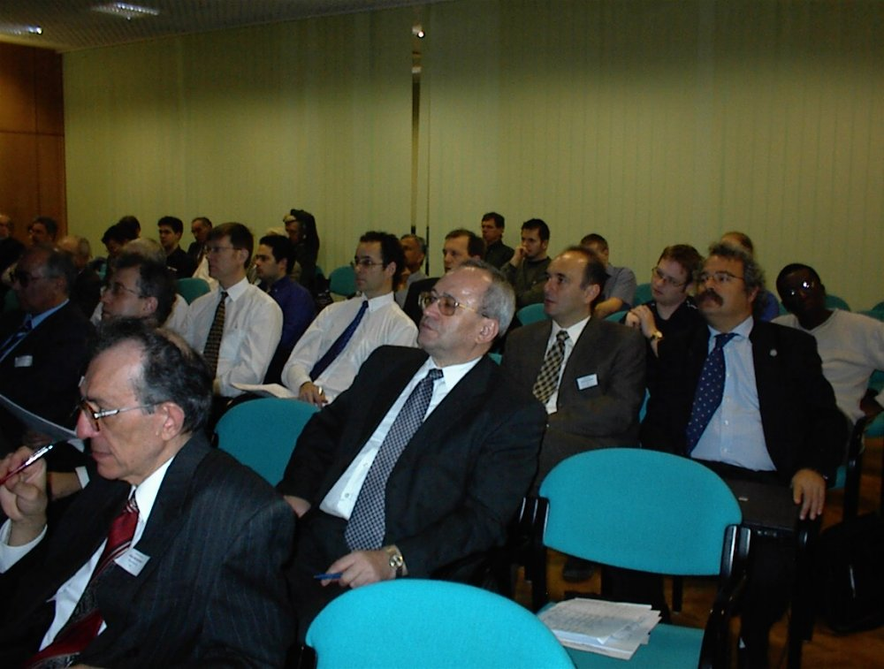

Ideal-ist Event
"Information Society Technologies in the Sixth Framework Programme„

Budapest Hungary
13th and 14th of November 2003
organized by the Quality Management Department of MTA SZTAKI & the Idealist5FP IST project.

http://istok.sztaki.hu/events/conference/

Goals

- Event topics
  - Presentations on IST of 6FP
  - Presentations on ideal-ist
  - Presentations on the experiences of the first and the second calls
  - Partner Search services

- Other arrangements
  - Networking (Individual presentations from participants)
  - Exhibition
  - Success stories
  - Tutorial on project management in the 6th Framework Programme
  - On-site consulting

Agenda

13th of November, 2003
9:00 - 9:30 | Registration
9:30 – 9:45 | Welcome
9:45 – 10:15 | IST in 6th FP  Experiences on the new instruments  Danielle Krekels - Alprocor, Belgium
10:15 - 10:45 | Hungarian experiences of the 1st and the 2nd calls  Vilmos Bognár - NCP Hungary
10:45 – 11:00 | Coffee break
11:00 - 11:30 | Idealist project  - Short introduction  - Partner search  Eva Feuer - MTA SZTAKI, Hungary
11:30 - 12:00 | How we Do it in IT in Denmark  Bent Egebart - BEI, Denmark
12:00 - 13:00 | IST Success Stories
13:00 – 14:00 | Lunch
14:00 - 15:00 | Informal Report  Participation of SMEs in Integrated Projects in FP6 IST Call 1  Danielle Krekels - Alprocor, Belgium
Parallel session
9:00 – 15:00 |  | Exhibition  On-site consulting
14th of November, 2003
09:00 – 11:00 |  | Tutorial on project management in the 6th FP  Paul Drath - Singleimage Ltd, UK
11:00 – 11:15 |  | Coffee break
11:15 – 13:00 |  | Tutorial on project management in the 6th FP  Paul Drath - Singleimage Ltd
13:00 – 14:00 |  | Lunch
14:00 – 16:00 |  | Tutorial on project management in the 6th FP  Paul Drath - Singleimage Ltd
Parallel session
9:00 – 16:00 |  | Exhibition  On-site consulting

Workshop participants

Participating European countries

Country Number of participants
Austria 2
Belgium 1
Bulgaria 1
Denmark 1
France 1
Greece 1
Hungary 30
Italy 1
Luxembourg 1
Slovakia 1
Slovenia 3
United Kingdom 3
Total 46

Participating organizations

ALPROCOR S.A
AltaCom Kft.
Austrian Information Industry
BEI
Budapest University of Technology and Economics
Bulgarian Academy of Sciences
CIM-EXP Ltd.
CNRS, LRI, Universite Paris-Sud
Csanády & Parrtners Consulting Ltd.
DSS Consulting Kft.
Eurocon d.o.o.
Genesys Consultancy
Holografika e.c.
Hungarica Sprl.
Hungarian Science and Technology Foundation
Infinity kft.
INNO INVENT EC
IRC Scotland
ISCN GmbH
IT CONSULT PRO RT.
Jozef Stefan Institute
KFKI
MAGYOSZ
Ministero dell'economia e delle finanze
Ministry of Education, Republic of Hungary
MTA SZTAKI
Novitech
Palsit
PTL Bt.
S.X. Software
Singleimage Limited
Synergon Rt
University of Szeged

Achievements

- The ideal-ist event " Information Society Technologies in the Sixth Framework Programme" held on Thursday and Friday, 13th and 14th November 2003 in Budapest, Hungary was a 2 days event with a workshop on project management.
- The event attracted participants from 11 European countries and Hungary.
- Follow up activities included that the presentations and the document about “Participation of SMEs in Integrated Projects in FP6 IST Call 1” were made accessible to be downloaded by the participants on the event’s website.

Feedback Form

The organizers received 15 questionnaires the results of which summarized in table

Category | Rating  5 means excellent, 1 means poor.
Organization of event | 4,4
Location of event | 4,3
Expectations | 4,2
Contents of presentations | 4,6
Information material | 4,6
Average | 4,42

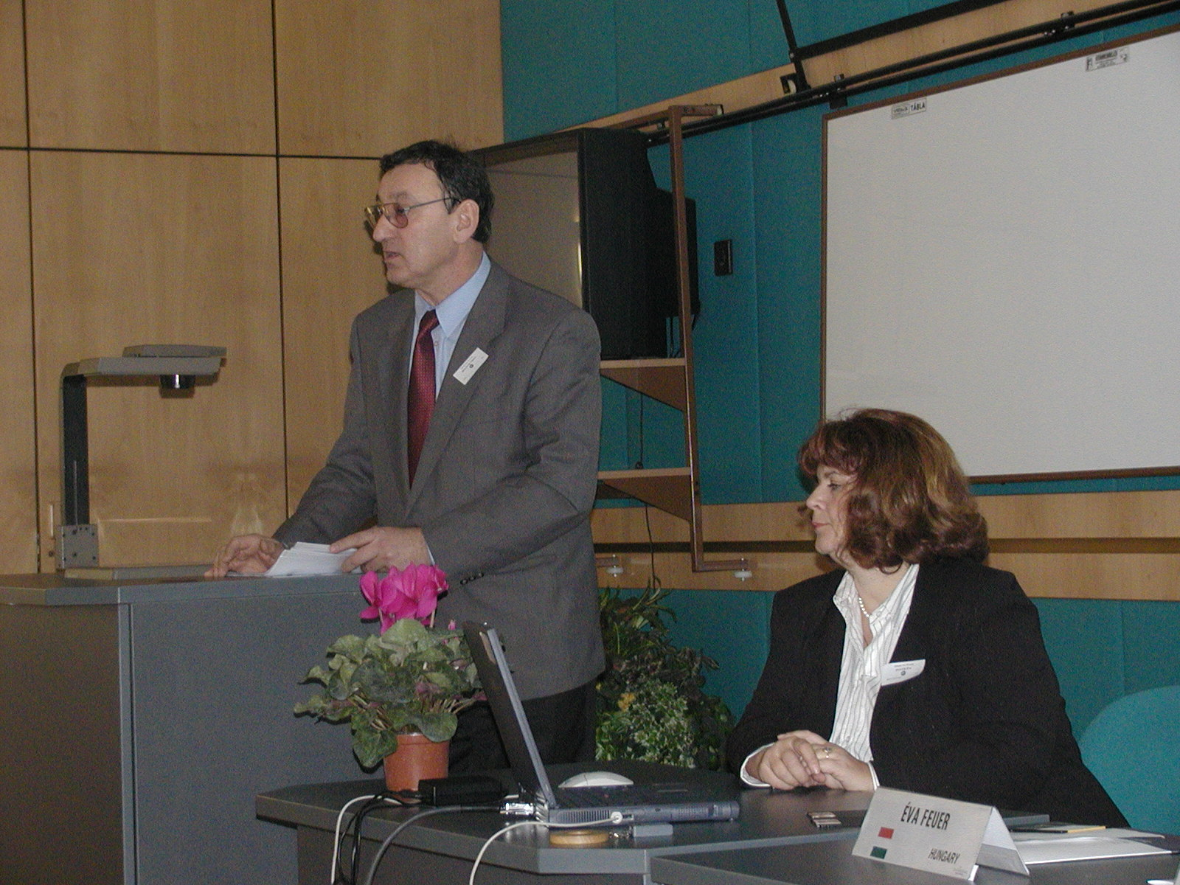

The 2nd CBSEnet Workshop
3rd and 4th April 2003
Budapest, Hungary
organized by the Quality Management Department of MTA SZTAKI & the CBSEnet project.
http://www.sztaki.hu/miro/cbsenet

Goals

- to enrich the current state of CBSE with the contribution of CBSE experts
- define the future trends, from industry and researchers, of CBSE
- discuss the Landscape document,

Agenda

3rd of April, 2003
Registration
Welcome
 | presented by Peter Inzelt director of MTA SZTAKI, Hungary
Introduction to the CBSEnet Project (results from the 1st Workshop)
 | Stefano De Panfilis (Engineering Ingegneria Informatica S.p.A.)
CBSE Landscape and Road-mapping
 | Arne Berre (SINTEF, Norway)
CBSE Process: Issues and Future Visions
 | Gerald Kotonya (Lancaster University)
Coffee break
Keynote: Software Technology and the 6th Framework Programme
 | Vassilis Kopanas (European Commission)
Trust Issues on CBSE
- | Keynote: CBSE and Dependable Systems
 | Ivica Crnkovic (Mälardalen University, Sweden)
- | Keynote: Trusted Component
 | Kung-Kiu Lau (Manchester University, UK)
Lunch
Parallel Group Discussions
-  - | Issues on Business and Finance  Issues on COTS and Legacy
Coffee break
Plenary Presentations of the results from the Group-work
4th of April, 2003
CBSE Landscape: Future Vision in Research Scenarios
 | Arne Berre (SINTEF, Norway)
CBSE State of the Practice and Experience Survey
 | Pedro Gutierrez (ESI, Spain)
Parallel Group Discussions on technology aspects
- | Issues on Specifications, Architecture (eServices), Composition/Adaptability, non-Functional/QoS, Management, ...
Coffee break (included)
Plenary Presentations of the results from the Group-work
Lunch
Future Work: Gap Analysis definition strategies and Road-mapping
 | Arne Berre (SINTEF, Norway)
Conclusions, Future CBSEnet Events and Actions
 | Stefano De Panfilis (Engineering Ingegneria Informatica S.p.A.)

Participants

Country Number of participants
Austria 1
Cyprus 1
Germany 1
Greece 5
Hungary 9
Italy 4
Norway 2
Spain 4
Sweden 1
UK 3
Colombia 1
Total 32

Achievements

- present the current version of the CBSE Landscape Document
- get involvement of the attending participating members to write specific parts of relevant chapters.
- Co-operation and combined workshop together with Colognet (CBD workpackage members).

Parallel sessions

- Modelling and Specification MDA vs CBSE
  - to include CBSE philosophy into MDA
  - Architectural Components can be built
  - Component description requires specific standardized approach

- eServices (Service oriented architecture, Quality of Service)
  - Support for extra-functional aspects, security, dependability, extended transactions, QoS
  - How to handle platform differences
  - Distributed cross-domain computing raises problems in the field of security
  - Standard processes for organisations that deliver services

